**Creation of Public and private Key and cloning through SSH**

1. Generating public/private rsa key pair.

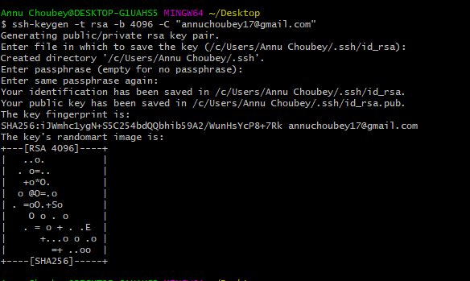

1. Adding SSH public Key

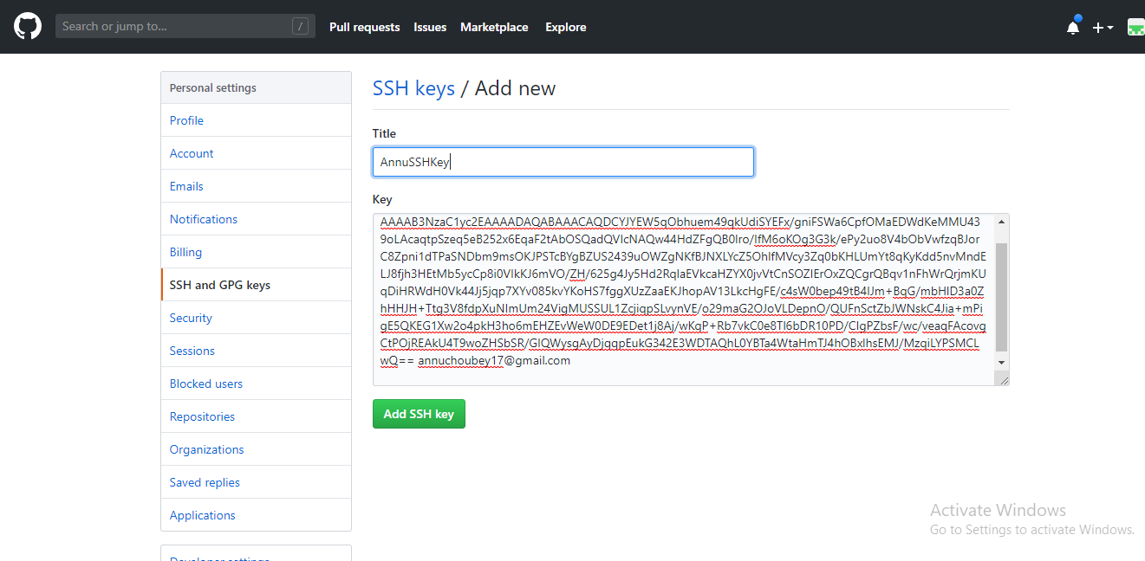

1. Created SSH key

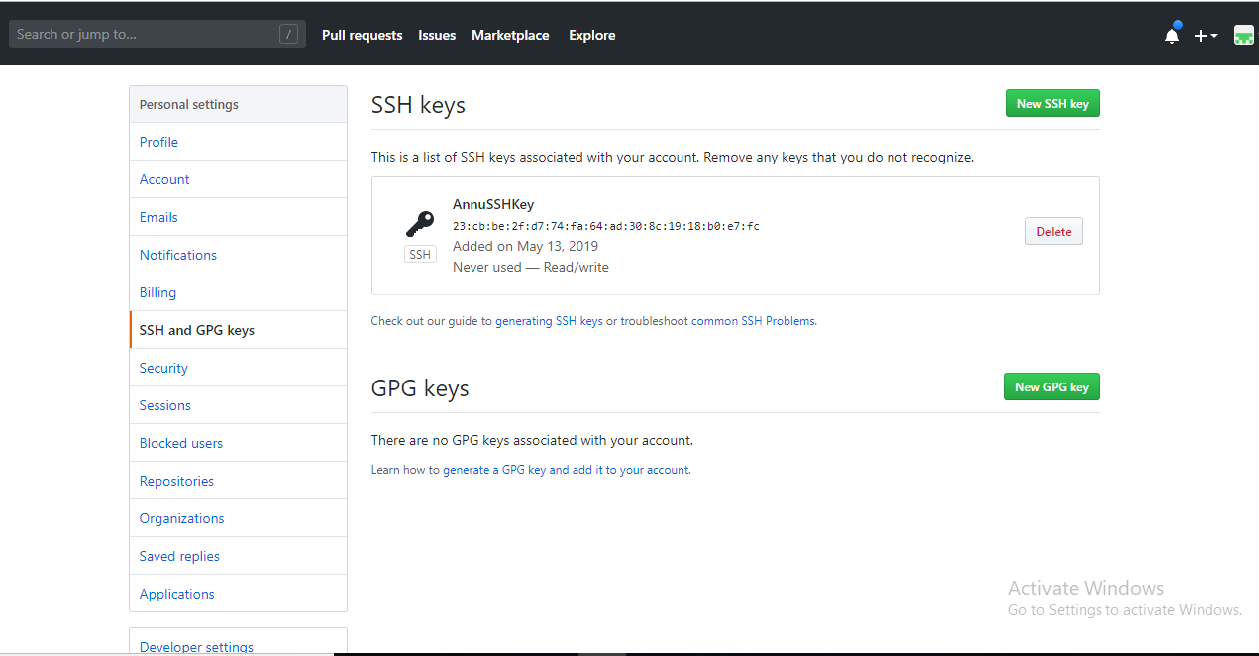

1. Clone with SSH in SqlServerTeam Repository

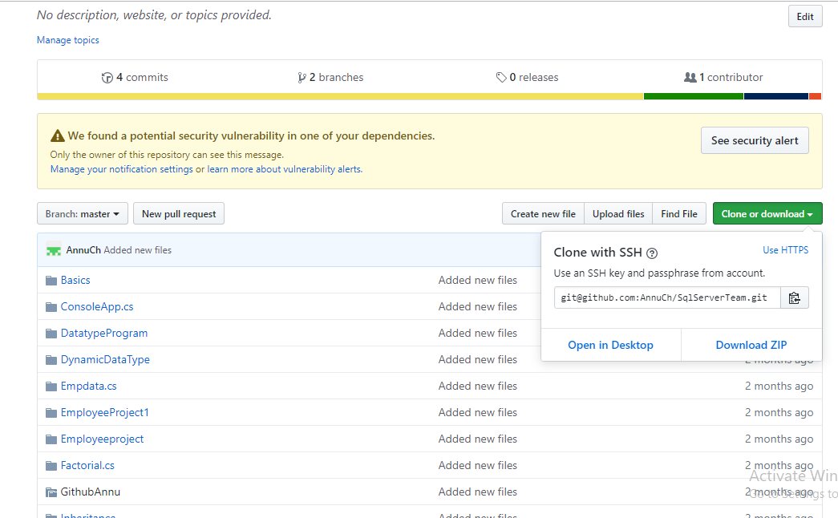

1. Cloning in Githbash.

